

0000.doc

MATHEMATICS: SPECIALIST 3CMAS/3DMAS SAMPLE EXAMINATION
RESOURCE-FREE

Section 7 of the New WACE Manual: General Information 2006–2009 outlines the policy on WACE examinations.

Further information about the WACE Examinations policy can be accessed from the Curriculum Council website at http://newwace.curriculum.wa.edu.au/pages/about_wace_manual.asp

The purpose for providing a sample examination is to provide teachers with an example of how the course will be examined. Further finetuning will be made to this sample in 2007 by the examination panel following consultation with teachers, measurement specialists and advice from the Assessment, Review and Moderation (ARM) panel.

The examination is in two parts, in line with recommendations of the ARM panel--a resource-free examination of 50 minutes, worth 40 marks, and a resource-rich examination of 100 minutes, worth 80 marks. CAS (Computer Algebra System) calculators are excluded in the resource-free part and included in the resource-rich part.




Western Australian Certificate of Education, Sample External Examination
Question/Answer Booklet

MATHEMATICS: SPECIALIST
3CMAS/3DMAS
Please place one of your student identification labels in this box.
WRITTEN PAPER
RESOURCE-FREE

Student Number: In figures

In words

Time allowed for this paper
Reading time before commencing work: Ten minutes
Working time for paper: Fifty minutes

Material required/recommended for this paper

To be provided by the supervisor
This Question/Answer Booklet

To be provided by the candidate
Standard items: Pens, pencils, eraser, correction fluid, highlighter

Important note to candidates
The standard items listed above and the Resource-free examination paper are the only items permitted on your table during the Resource-free examination. When directed, you will place all other items and the Resource-rich examination paper under your chair.

This paper is for students who have completed Units 3CMAS and 3DMAS as their last pair of units.
Structure of this paper

Working time | Number of questions available | Number of questions to be attempted | Marks
50 minutes | 6 | 6 | 40
 |  | [Total marks] | 40

This paper has SIX (6) questions. Attempt ALL questions.

Question | Marks
1 | 04
2 | 06
3 | 07
4 | 10
5 | 06
6 | 07
Total marks | 40

Instructions to candidates

1. The rules for the conduct of Curriculum Council examinations are detailed in the Student Information Handbook. Sitting this examination implies that you agree to abide by these rules.

2. Write your answers in the spaces provided in this Question/Answer Booklet. Spare pages may be found at the end of the booklet. If you need to use them, indicate in the original answer space where the answer is continued (i.e. give the page number).

3. A blue or black ballpoint or ink pen should be used.

4. It is recommended that you do not use pencil except in diagrams.

5. Show all your working clearly. Your working should be in sufficient detail to allow your answers to be checked readily and for marks to be awarded for reasoning. Correct answers given without supporting reasoning may not be allocated full marks. Incorrect answers given without supporting reasoning cannot be allocated any marks. If you repeat an answer to any question, ensure that you cancel the answer you do not wish to have marked.
RESOURCE-FREE

This paper has SIX (6) questions. Attempt ALL questions.

Question 1 [4 marks]
Given 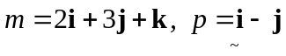 and 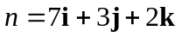:
- Find 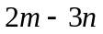.
[2 marks]

- Find 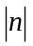
[2 marks]

Question 2 [6 marks]
- Find 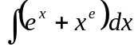
[3 marks]

- Show that 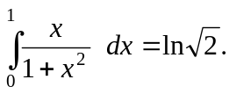
[3 marks]

Question 3 [7 marks]
A curve has parametric equations:
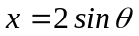 and 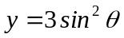.
- Find an expression for 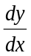 and hence find the equation of the tangent to the curve at the point where 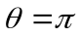.
[5 marks]

- Determine the Cartesian equation of the curve.
[2 marks]

Question 4 [10 marks]
- Find the solution to 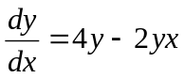 satisfying 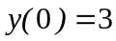.
[5 marks]

- The graphs of the functions sin x and |sin 2x| for 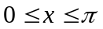 are shown.

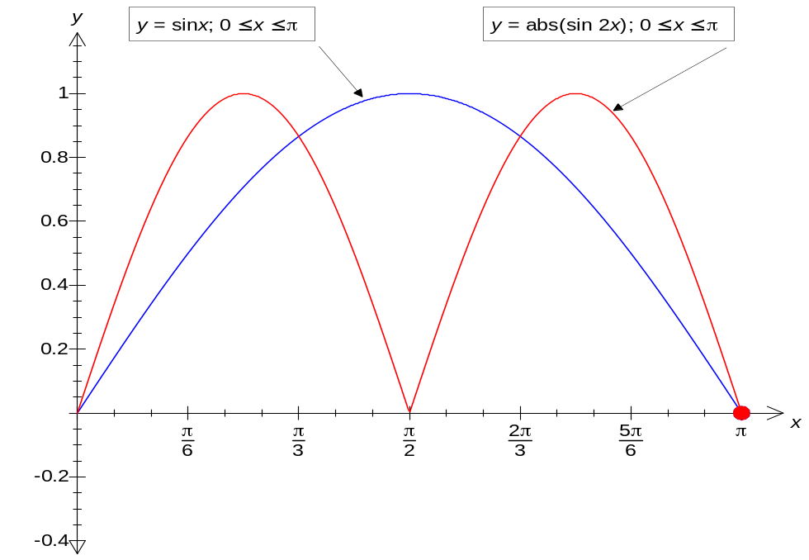

Use algebra and explaining your reasoning, solve exactly the inequality |sin 2x| sin x over the interval
[5 marks]

Question 5 [6 marks]
- Verify that:
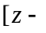cis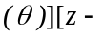cis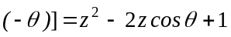
[3 marks]

- Sketch the following subset of the complex plane:
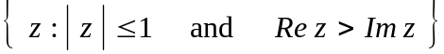
[3 marks]

Im z

Re z

Question 7 [7 marks]
The sum of the products of two consecutive positive integers seems to have the form,
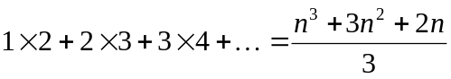

Prove that this conjecture is true for all positive integers, n.

THIS PAGE HAS BEEN LEFT BLANK INTENTIONALLY

ACKNOWLEDGEMENTS

Published by the Curriculum Council of Western Australia
27 Walters Drive
OSBORNE PARK WA 6017

